

**UNIVERSITY EXAMINATIONS FOR THE AWARD OF THE DEGREE OF BACHELOR OF EDUCATION**

**2021/2022 ACADEMIC YEAR**

**JANUARY SEMESTER 2022**

**UNIT CODE: LADM 1203**

**UNIT TITLE: PHYSICS FOR AGRICULTURISTS**

**DATE: APRIL 2022**  **TIME: 2 HOURS**

**INSTRUCTIONS**

1. Answer **question one** and **any other two** questions
2. Do **not** write anything on this question paper
3. Do **not** write in the page margins of the answer booklet
4. Begin each question answer on a new page

**Use the following constants where necessary:**

Electron charge = 1.6 x 10-19 C, mass of an electron = 9.11 x 10-31 Kg

µ0 = 4 x 10-7 H/m, 0= 8.854 x 10-12 F/m, k= 8.99 x 109 N.m2/C2

**QUESTION 1 (COMPULSORY) (30 MARKS)**

1. With the aid of a well labelled diagram, show the relationship between the angle of incidence to the angle of reflection. (5mks)
2. Discuss interference as explained in the Young’s double slit experiment (5mks)
3. Locate the image as seen by the observer in the diagram below (4mks)

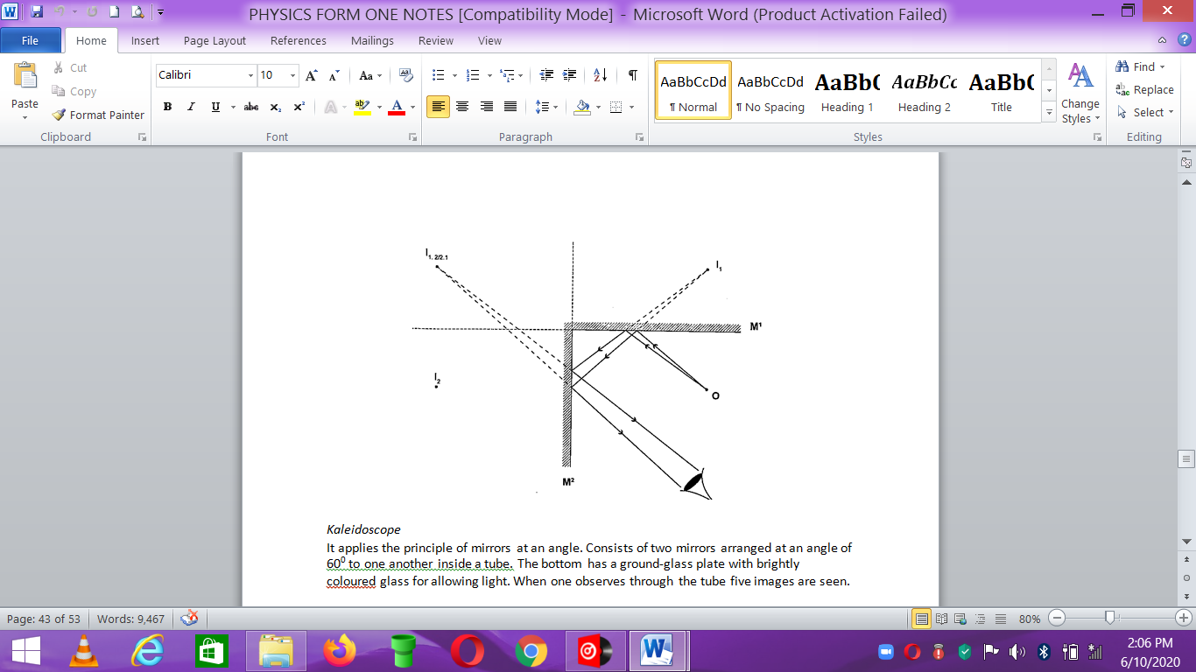

1. Show that the electric charge (q) distribution throughout out the volume of a sphere of radius R and total charge qt is given by **qt = q(r3/R3)** where r is the radius of the Gaussian surface. (5mks)
2. Derive an expression for the effective capacitance for capacitors in parallel with the aid of a diagram and find the capacitance in such a circuit which has 3 capacitors whose values are C1=12.0 pF,

C2= 5.3 µF and C3= 4.5 nF. (5mks)

1. Given the set up below where $c_{1}=12.0 pF, c_{2}=5.3 μF and c_{3}=4.5 μF$
2. Find the equivalent capacitance of the combination (3mks)
3. If a potential V= 12.5 volts is applied to the terminals, what is the charge on $c_{1}$ (3mks)

B

A

C3

C2

C1

**QUESTION 2 (20 MARKS)**

1. An astronaut weighs 800 N on earth. On the moon he weighs 100 N. Calculate the moons’

gravitational strength. (Take g = 9.8 N/kg) (3mks)

1. The length of a spring is 20.0 cm. its length becomes 40.0 cm when supporting a weight of

10.0 N. calculate the length of the spring when supporting a weight of:

a) 5 N b) 12 N c) 400 N (6mks)

1. A body covers a distance of 20 m in 5 seconds. It rests for 20 seconds and finally covers a distance of 100 m in 30 seconds. Calculate the average speed. (4mks)
2. A body moving with uniform acceleration of 5 m/s2 covers a distance of 640 m. if its initial velocity was 100 m/s. Calculate its final velocity (4mks)
3. A body is uniformly accelerated from rest to a final velocity of 150 m/s in 20 seconds. Calculate the distance covered. (3mks)

**QUESTION 3 (20MARKS)**

1. A stone is projected vertically upwards with a velocity of 40 m/s from the ground.

Calculate,

1. The time it takes to attain maximum height (3mks)
2. The time of flight (3mks)
3. The maximum height reached (3mks)
4. The velocity with which it lands on the ground. (take g=10m/s) (3mks)
5. A girl claps her hands once at a distance 400 m from a vertical cliff. If the temperature in the surrounding is 10 0C, how long does it take for her to hear the echo? (4mks)
6. Determine the size, position and nature of the image of an object 5.0 cm tall, placed on the principal axis of a convex mirror of focal length 15 cm, at a distance 35 cm from the mirror (4mks)

**QUESTION 4 (20MARKS)**

1. Intensity of light decreases with distance. Explain with the aid of a diagram (6mks)
2. A concave mirror produces a real image 1 cm tall of an object 2.5 mm tall placed 5 cm from the mirror. Find the position of the image and the focal length of the mirror (10mks)
3. Derive an equation for the effective capacitance of three capacitors C1, C2 and C3 connected in series. (4mks)

**QUESTION 5 (20 MARKS)**

1. Consider three point charges q1 = -1.2 µC, q2 = +3.7 µC and q3 = -2.3 µC separated by distances r12= 15 cm and r13 = 10 cm. Charge q1 is situated at the origin while charge q2 and q3 are situated at the x and y axis respectively.

Calculate the net force acting on the charge q1 due to the charge q2 and q3 (6mks)

1. A man runs 800m due North in 100 seconds, followed by 400m due South in 80 seconds. Calculate,
2. His average speed (5mks)
3. His average velocity (3mks)
4. His change in velocity for the whole journey (2mks)
5. Discuss any two factors affecting the speed of sound in air (4mks)